BULocalization For Translators

How To Translate The Program Into Your Langiage With This Tool?

Let's see how to do this on the following example. We have program ZipSolution installed in C:\Program files\ZipSolution – 4.7 and we need to localize it into the Spanish. Folder locals is located in C:\Program files\ZipSolution – 4.7\locals

a. Download and unpack BULocalization(http://www.sourceforge.net/projects/bulocalization)

b. Run BULocalization

c. Let's set your translator's setting here

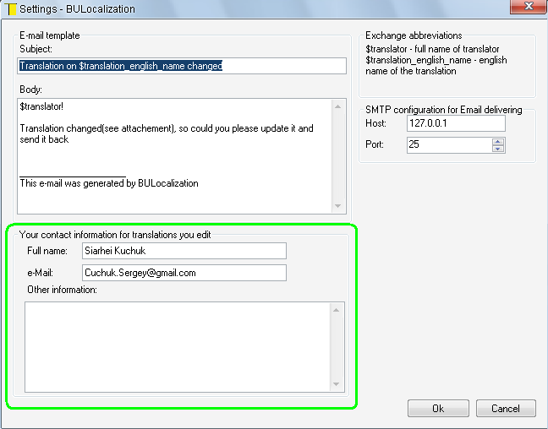
d. Let's open the localization project of installed software
Press Ctrl+O or go to menu 'Localization Project\Open...'
Open in dialog appeared the C:\Program files\ZipSolution – 4.7\locals

e. Double click on existing translation in the list if you want to update it or add the new translation via context menu as it shown on a picture below and the double click on it

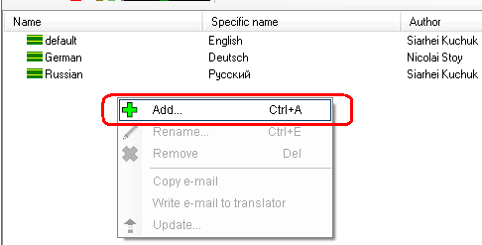
f. After double click an editor will occur shown on the picture below

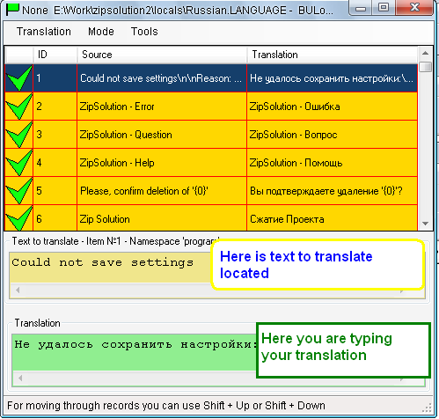
g. Let's test your translation

See manual to view how to do this

h. Let's get the translation file created

The file you should send is
C:\Program files\ZipSolution – 4.7\locals\Spanish.Language

